1. Racial Leadership Member Table:

This table show the “Racial leaderships Members “.

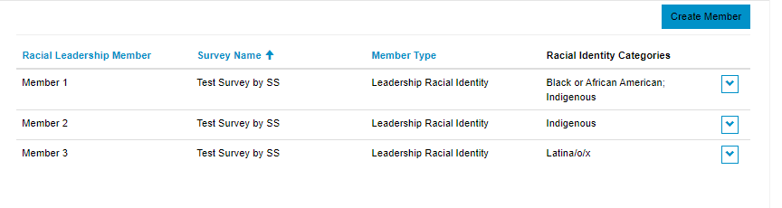

User can create and edit these members.

If user navigate to “**Create Members**” from “the “**Racial leaderships**” section then user need to select “Member Type” from dropdown as “Leadership Racial Identity”.

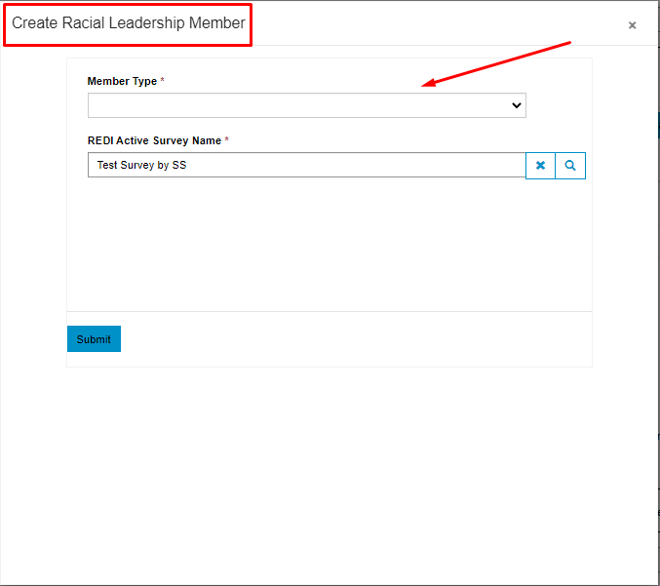

After selecting “Member Type”, **relevant fields** will show to user according to **opened Modal type**.

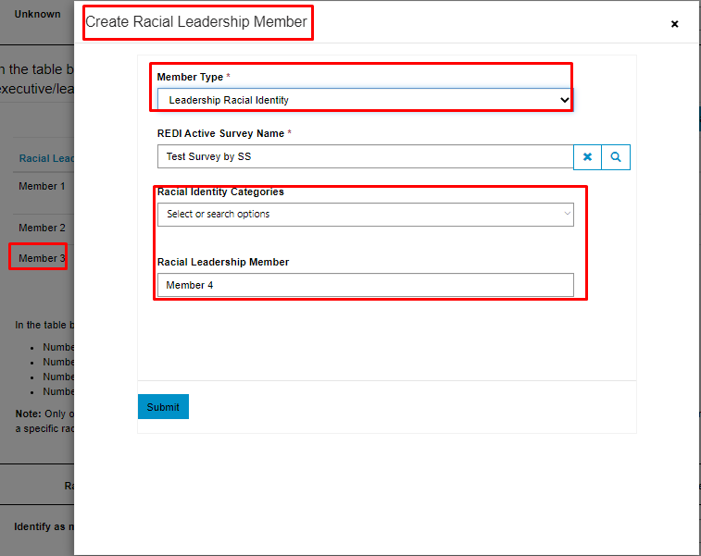

And if user want to **Edit** any section, then he will also see the relevant fields.

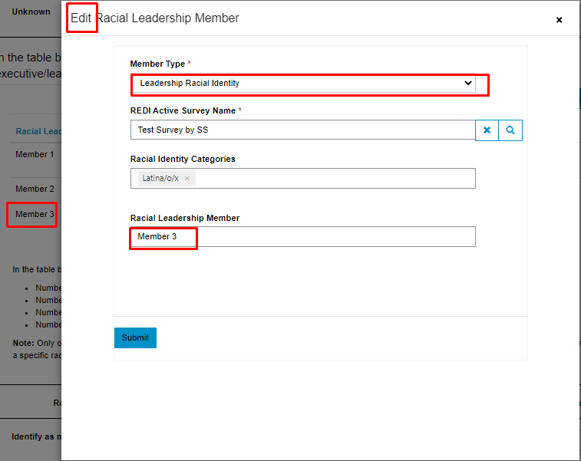

Any record can be edited.

**Note:** Yesterday we have an issue, if there is not any record into any table like “Racial leadership” then “survey name” was not appearing into “REDI Active survey name” field,   
Today I have fix this.

**Note**: Meanwhile as you mentioned while editing the records “Few irrelevant fields were showing, I had fix this”.

1. Meanwhile, If there is not any “member” into tables, then while creating “Member”, Member name will be auto populated as ‘Member 1’
2. I have created **four fields “Racial Leadership Member”, “Racial Board Member”, “Gender Leadership Member” and “Gender Board Member”.**These 4 fields are basically containing the “**Member names**”for the **“Racial leadership, racial board, gender leadership, and gender board”.   
     
   So,** while adding records into CRM from source you need to map these fields for different “Member Type”. So that record appears into survey tables**.   
     
   Thanks**